Hon. Chairman:  Mr Duncan Mason  Email: enquiries@theharrymiddletongift.org  111111111111111111111111 | 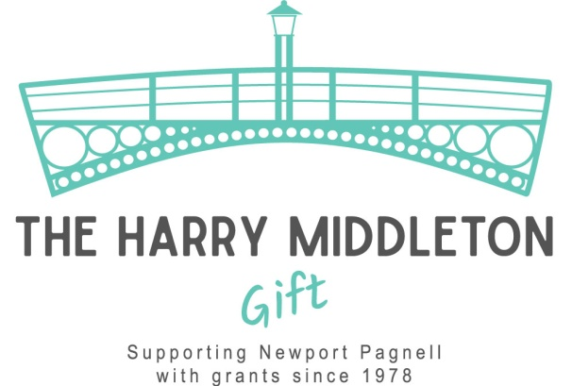  Registered Charity Number: 258534  Website:  https://theharrymiddletongift.org | Hon. Secretary:  Craig Phillips  11 Fair Isle View  Oakridge Park  Milton Keynes  MK14 6FN  Tel: 07887 620570  Email:  enquiries@theharrymiddletongift.org

Application for a grant from The Harry Middleton Gift

Criteria

The foundation of the Harry Middleton Gift Fund was laid when in 1956, Harry Middleton went to the
Urban District Council with a gift to the town of 5000 shares in the Mining Corporation of Canada and Noranda Mines. The Council was to use the net income from the shares for the general benefit of the inhabitants of Newport Pagnell.

Applications for a grant are always discussed and considered very carefully by the trustees. Applications should meet the following criteria:

- As mentioned above, in 1956 Mr. Harry Middleton made a substantial gift to the town, in the first instance for the purpose of providing and maintaining a proper Swimming Pool in the Town, with the balance being used for the general benefit of the inhabitants of Newport Pagnell. Therefore, to honour Mr. Harry Middleton’s wishes, the primary consideration for all applications is whether the grant applied for will primarily benefit the residents of Newport Pagnell.
- We prioritise applications for items of a capital nature. However, all grant applications will be considered on their merits.
- Any application should be supported by proper estimates where applicable and accompanied by the latest set of accounts of the applying organisation.
- Applications should be made prior to purchase or payment for works.
- We are unable to make grants to individuals, or for items that would normally be the responsibility of local councils financed from taxes. Likewise, we are unable to make grants to other charitable organisations which are set up to raise and distribute funds, i.e., grants can only be made to end user organisations.
If you feel that your requirement falls within the above criteria, please complete the form overleaf and return it to the Secretary (contact details above). If in doubt, contact the Secretary direct who will discuss it with
you. Alternatively complete and return the form. Nothing is lost by applying.

Application Process

- Please complete the application form overleaf and return to the Hon. Secretary (address at top of page).
- Your application will be acknowledged when received by the Hon. Secretary.
- The Harry Middleton Gift trustees meet approximately every three months, and your application will be submitted to the next available meeting, (you will be notified of the date of the meeting as soon as it is known).
- Following the meeting of trustees, the Hon. Secretary will write to you with the outcome of your application.

If you have and questions or queries, please do not hesitate to contact the Hon. Secretary.

Application for a grant from The Harry Middleton Gift
Organisation Name:
Contact Name:
Position in Organisation:
Landline Telephone Number: |  |  | Mobile Telephone Number:
Email Address:
Contact Address:
Activities of Organisation:

Number of Members: |  | Subscription fee, if any: |  |  | £
Other Sources of Income:
Estimated Annual Income: | £
Estimated Annual Expenditure: | £
Current Cash / Bank Assets: (Please enclose latest set of accounts) | £
Purpose of Grant Application: (Continue on extra sheet if needed)

Total estimated cost of Project: | £
Amount of grant requested and how it will be spent: (Enclose estimates or price lists where available and continue on a separate sheet if required) | Item: |  |  |  | Cost: (£)
How will balance (if any) be funded?
Signed: |  |  |  | Date:
Completed forms should be sent to:
The Hon. Secretary, Mr Craig Phillips, 11 Fair Isle View, Oakridge Park, Milton Keynes MK14 6FN.
Email: enquiries@theharrymiddletongift.org

For THMG use only:
Reference number: |  | Date grant approved / rejected:
Amount of grant approved: |  | Date paid:

